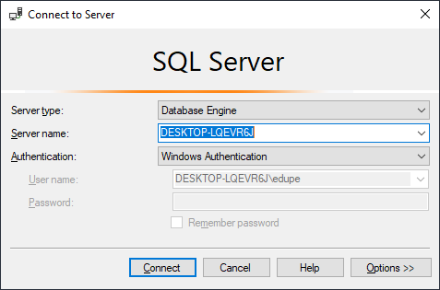

7 Tables of imported normalized files 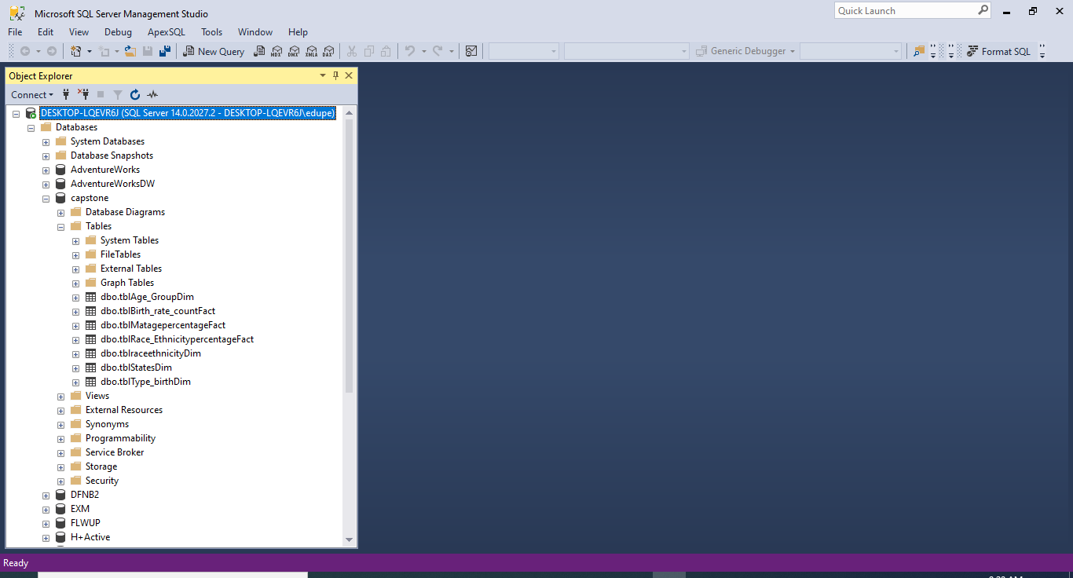

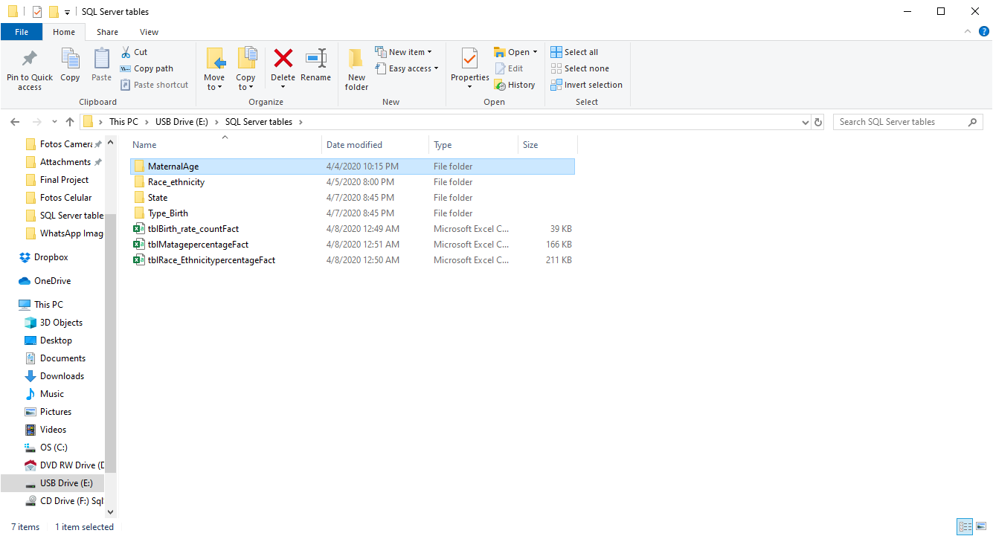

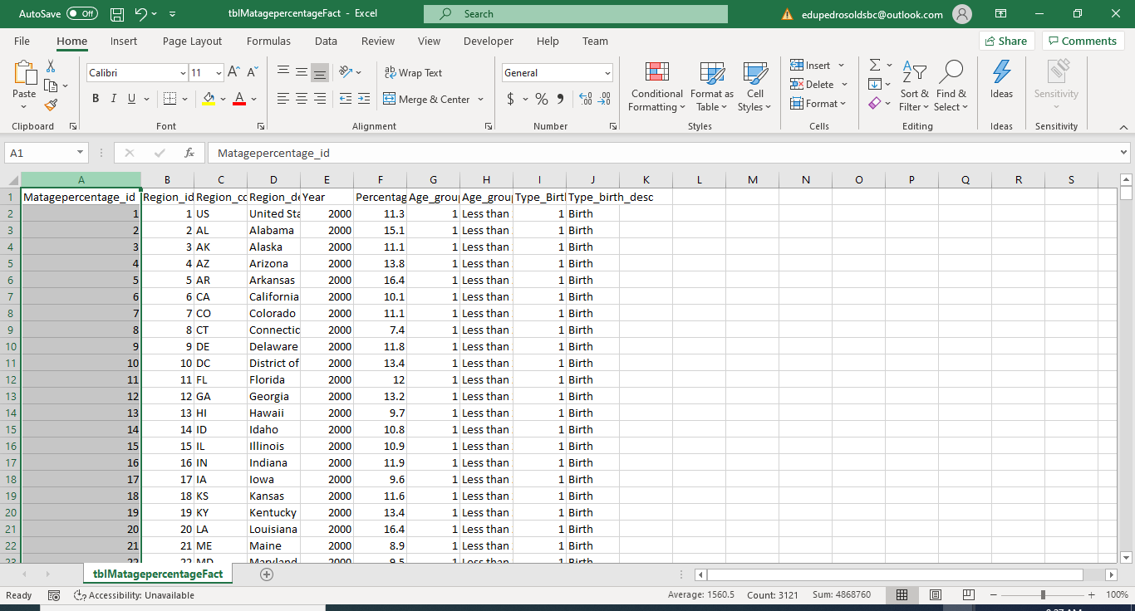

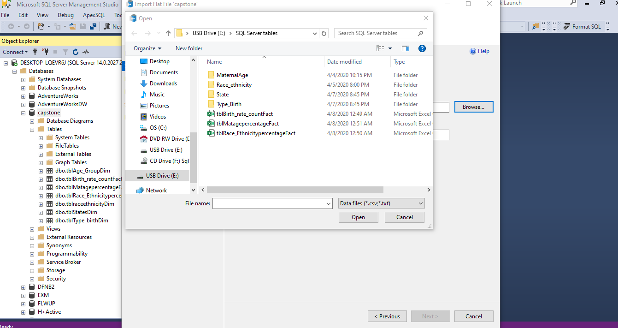

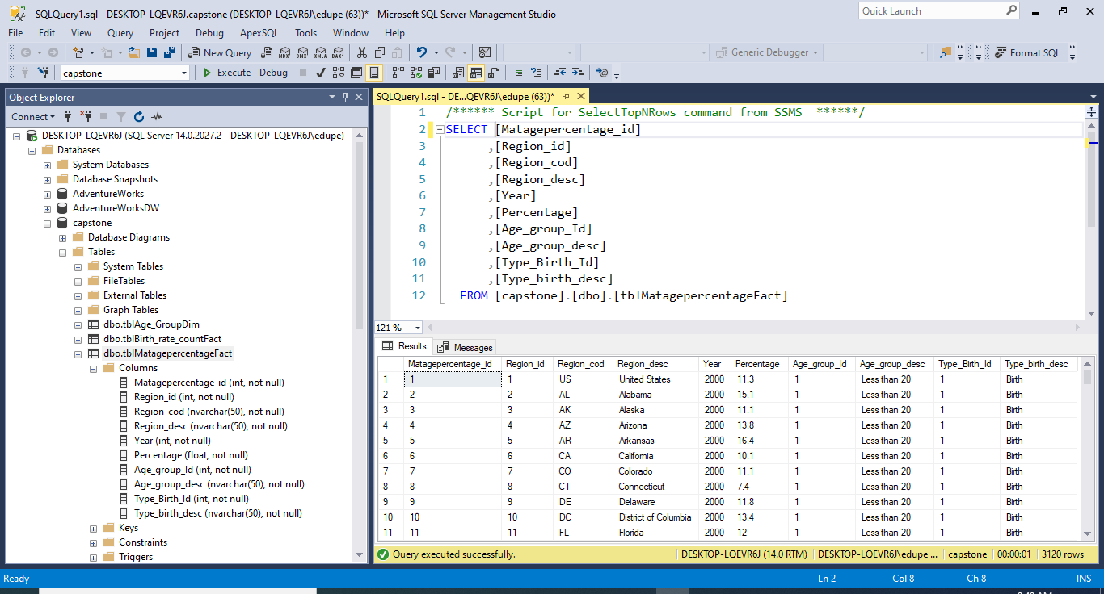

Primary Key and Foreign Key

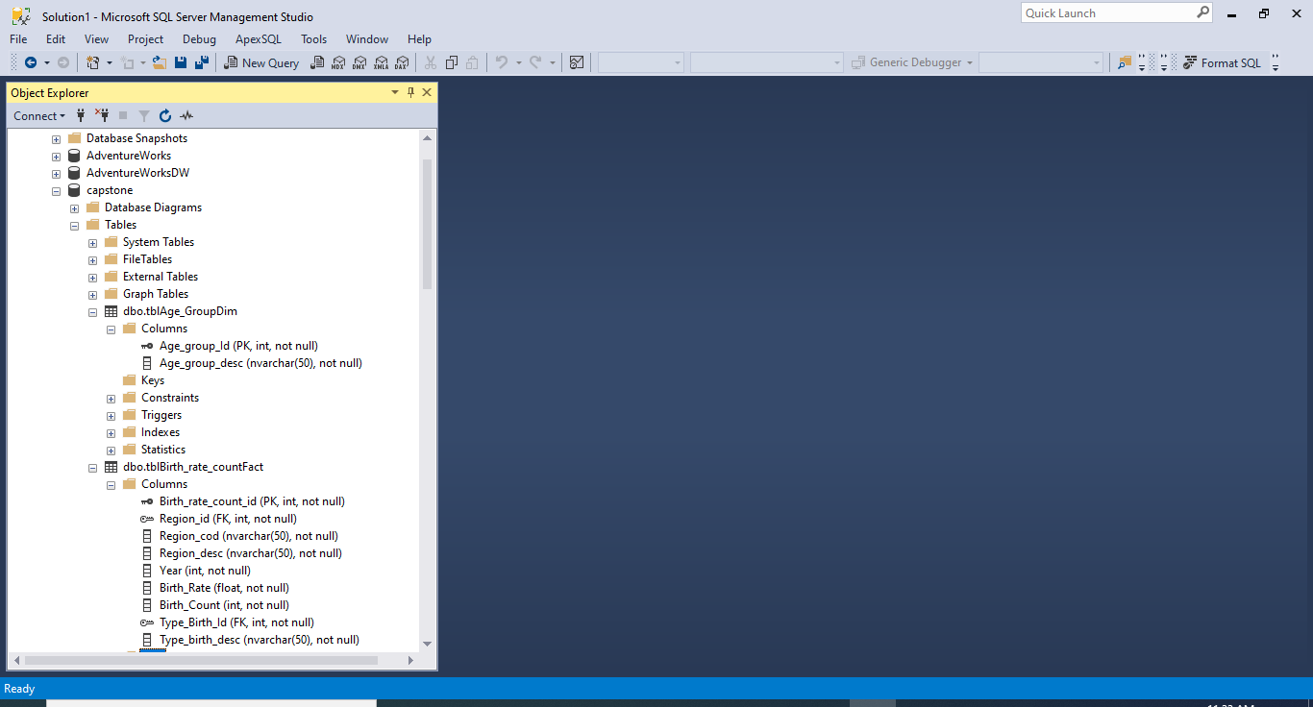

USE [master]

GO

/****** Object: Database [capstone] Script Date: 4/8/2020 11:38:05 AM ******/

CREATE DATABASE [capstone]

CONTAINMENT = NONE

ON PRIMARY

( NAME = N'capstone', FILENAME = N'C:\Program Files\Microsoft SQL Server\MSSQL14.MSSQLSERVER\MSSQL\DATA\capstone.mdf' , SIZE = 8192KB , MAXSIZE = UNLIMITED, FILEGROWTH = 65536KB )

LOG ON

( NAME = N'capstone_log', FILENAME = N'C:\Program Files\Microsoft SQL Server\MSSQL14.MSSQLSERVER\MSSQL\DATA\capstone_log.ldf' , SIZE = 8192KB , MAXSIZE = 2048GB , FILEGROWTH = 65536KB )

GO

ALTER DATABASE [capstone] SET COMPATIBILITY_LEVEL = 140

GO

IF (1 = FULLTEXTSERVICEPROPERTY('IsFullTextInstalled'))

begin

EXEC [capstone].[dbo].[sp_fulltext_database] @action = 'enable'

end

GO

ALTER DATABASE [capstone] SET ANSI_NULL_DEFAULT OFF

GO

ALTER DATABASE [capstone] SET ANSI_NULLS OFF

GO

ALTER DATABASE [capstone] SET ANSI_PADDING OFF

GO

ALTER DATABASE [capstone] SET ANSI_WARNINGS OFF

GO

ALTER DATABASE [capstone] SET ARITHABORT OFF

GO

ALTER DATABASE [capstone] SET AUTO_CLOSE OFF

GO

ALTER DATABASE [capstone] SET AUTO_SHRINK OFF

GO

ALTER DATABASE [capstone] SET AUTO_UPDATE_STATISTICS ON

GO

ALTER DATABASE [capstone] SET CURSOR_CLOSE_ON_COMMIT OFF

GO

ALTER DATABASE [capstone] SET CURSOR_DEFAULT GLOBAL

GO

ALTER DATABASE [capstone] SET CONCAT_NULL_YIELDS_NULL OFF

GO

ALTER DATABASE [capstone] SET NUMERIC_ROUNDABORT OFF

GO

ALTER DATABASE [capstone] SET QUOTED_IDENTIFIER OFF

GO

ALTER DATABASE [capstone] SET RECURSIVE_TRIGGERS OFF

GO

ALTER DATABASE [capstone] SET DISABLE_BROKER

GO

ALTER DATABASE [capstone] SET AUTO_UPDATE_STATISTICS_ASYNC OFF

GO

ALTER DATABASE [capstone] SET DATE_CORRELATION_OPTIMIZATION OFF

GO

ALTER DATABASE [capstone] SET TRUSTWORTHY OFF

GO

ALTER DATABASE [capstone] SET ALLOW_SNAPSHOT_ISOLATION OFF

GO

ALTER DATABASE [capstone] SET PARAMETERIZATION SIMPLE

GO

ALTER DATABASE [capstone] SET READ_COMMITTED_SNAPSHOT OFF

GO

ALTER DATABASE [capstone] SET HONOR_BROKER_PRIORITY OFF

GO

ALTER DATABASE [capstone] SET RECOVERY FULL

GO

ALTER DATABASE [capstone] SET MULTI_USER

GO

ALTER DATABASE [capstone] SET PAGE_VERIFY CHECKSUM

GO

ALTER DATABASE [capstone] SET DB_CHAINING OFF

GO

ALTER DATABASE [capstone] SET FILESTREAM( NON_TRANSACTED_ACCESS = OFF )

GO

ALTER DATABASE [capstone] SET TARGET_RECOVERY_TIME = 60 SECONDS

GO

ALTER DATABASE [capstone] SET DELAYED_DURABILITY = DISABLED

GO

EXEC sys.sp_db_vardecimal_storage_format N'capstone', N'ON'

GO

ALTER DATABASE [capstone] SET QUERY_STORE = OFF

GO

USE [capstone]

GO

/****** Object: Table [dbo].[tblAge_GroupDim] Script Date: 4/8/2020 11:38:06 AM ******/

SET ANSI_NULLS ON

GO

SET QUOTED_IDENTIFIER ON

GO

CREATE TABLE [dbo].[tblAge_GroupDim](

[Age_group_Id] [int] NOT NULL,

[Age_group_desc] [nvarchar](50) NOT NULL,

CONSTRAINT [PK_tblAge_GroupDim] PRIMARY KEY CLUSTERED

(

[Age_group_Id] ASC

)WITH (PAD_INDEX = OFF, STATISTICS_NORECOMPUTE = OFF, IGNORE_DUP_KEY = OFF, ALLOW_ROW_LOCKS = ON, ALLOW_PAGE_LOCKS = ON) ON [PRIMARY]

) ON [PRIMARY]

GO

/****** Object: Table [dbo].[tblBirth_rate_countFact] Script Date: 4/8/2020 11:38:07 AM ******/

SET ANSI_NULLS ON

GO

SET QUOTED_IDENTIFIER ON

GO

CREATE TABLE [dbo].[tblBirth_rate_countFact](

[Birth_rate_count_id] [int] NOT NULL,

[Region_id] [int] NOT NULL,

[Region_cod] [nvarchar](50) NOT NULL,

[Region_desc] [nvarchar](50) NOT NULL,

[Year] [int] NOT NULL,

[Birth_Rate] [float] NOT NULL,

[Birth_Count] [int] NOT NULL,

[Type_Birth_Id] [int] NOT NULL,

[Type_birth_desc] [nvarchar](50) NOT NULL,

CONSTRAINT [PK_tblBirth_rate_countFact] PRIMARY KEY CLUSTERED

(

[Birth_rate_count_id] ASC

)WITH (PAD_INDEX = OFF, STATISTICS_NORECOMPUTE = OFF, IGNORE_DUP_KEY = OFF, ALLOW_ROW_LOCKS = ON, ALLOW_PAGE_LOCKS = ON) ON [PRIMARY]

) ON [PRIMARY]

GO

/****** Object: Table [dbo].[tblMatagepercentageFact] Script Date: 4/8/2020 11:38:07 AM ******/

SET ANSI_NULLS ON

GO

SET QUOTED_IDENTIFIER ON

GO

CREATE TABLE [dbo].[tblMatagepercentageFact](

[Matagepercentage_id] [int] NOT NULL,

[Region_id] [int] NOT NULL,

[Region_cod] [nvarchar](50) NOT NULL,

[Region_desc] [nvarchar](50) NOT NULL,

[Year] [int] NOT NULL,

[Percentage] [float] NOT NULL,

[Age_group_Id] [int] NOT NULL,

[Age_group_desc] [nvarchar](50) NOT NULL,

[Type_Birth_Id] [int] NOT NULL,

[Type_birth_desc] [nvarchar](50) NOT NULL,

CONSTRAINT [PK_tblMatagepercentageFact] PRIMARY KEY CLUSTERED

(

[Matagepercentage_id] ASC

)WITH (PAD_INDEX = OFF, STATISTICS_NORECOMPUTE = OFF, IGNORE_DUP_KEY = OFF, ALLOW_ROW_LOCKS = ON, ALLOW_PAGE_LOCKS = ON) ON [PRIMARY]

) ON [PRIMARY]

GO

/****** Object: Table [dbo].[tblRace_EthnicitypercentageFact] Script Date: 4/8/2020 11:38:07 AM ******/

SET ANSI_NULLS ON

GO

SET QUOTED_IDENTIFIER ON

GO

CREATE TABLE [dbo].[tblRace_EthnicitypercentageFact](

[Race_Ethinicitypercentage_id] [int] NOT NULL,

[Region_id] [int] NOT NULL,

[Region_cod] [nvarchar](50) NOT NULL,

[Region_desc] [nvarchar](50) NOT NULL,

[Year] [int] NOT NULL,

[Percentage] [float] NOT NULL,

[Race_ethnicity_id] [int] NOT NULL,

[Race_ethnicity_desc] [nvarchar](50) NOT NULL,

[Type_Birth_Id] [int] NOT NULL,

[Type_birth_desc] [nvarchar](50) NOT NULL,

CONSTRAINT [PK_tblRace_EthnicitypercentageFact] PRIMARY KEY CLUSTERED

(

[Race_Ethinicitypercentage_id] ASC

)WITH (PAD_INDEX = OFF, STATISTICS_NORECOMPUTE = OFF, IGNORE_DUP_KEY = OFF, ALLOW_ROW_LOCKS = ON, ALLOW_PAGE_LOCKS = ON) ON [PRIMARY]

) ON [PRIMARY]

GO

/****** Object: Table [dbo].[tblraceethnicityDim] Script Date: 4/8/2020 11:38:07 AM ******/

SET ANSI_NULLS ON

GO

SET QUOTED_IDENTIFIER ON

GO

CREATE TABLE [dbo].[tblraceethnicityDim](

[Race_ethnicity_id] [int] NOT NULL,

[Race_ethnicity_desc] [nvarchar](50) NOT NULL,

CONSTRAINT [PK_tblraceethnicityDim] PRIMARY KEY CLUSTERED

(

[Race_ethnicity_id] ASC

)WITH (PAD_INDEX = OFF, STATISTICS_NORECOMPUTE = OFF, IGNORE_DUP_KEY = OFF, ALLOW_ROW_LOCKS = ON, ALLOW_PAGE_LOCKS = ON) ON [PRIMARY]

) ON [PRIMARY]

GO

/****** Object: Table [dbo].[tblStatesDim] Script Date: 4/8/2020 11:38:08 AM ******/

SET ANSI_NULLS ON

GO

SET QUOTED_IDENTIFIER ON

GO

CREATE TABLE [dbo].[tblStatesDim](

[Region_id] [int] NOT NULL,

[Region] [nvarchar](50) NOT NULL,

[State_desc] [nvarchar](50) NOT NULL,

CONSTRAINT [PK_tblStatesDim] PRIMARY KEY CLUSTERED

(

[Region_id] ASC

)WITH (PAD_INDEX = OFF, STATISTICS_NORECOMPUTE = OFF, IGNORE_DUP_KEY = OFF, ALLOW_ROW_LOCKS = ON, ALLOW_PAGE_LOCKS = ON) ON [PRIMARY]

) ON [PRIMARY]

GO

/****** Object: Table [dbo].[tblType_birthDim] Script Date: 4/8/2020 11:38:08 AM ******/

SET ANSI_NULLS ON

GO

SET QUOTED_IDENTIFIER ON

GO

CREATE TABLE [dbo].[tblType_birthDim](

[Type_Birth_Id] [int] NOT NULL,

[Type_birth_desc] [nvarchar](50) NOT NULL,

CONSTRAINT [PK_tblType_birthDim] PRIMARY KEY CLUSTERED

(

[Type_Birth_Id] ASC

)WITH (PAD_INDEX = OFF, STATISTICS_NORECOMPUTE = OFF, IGNORE_DUP_KEY = OFF, ALLOW_ROW_LOCKS = ON, ALLOW_PAGE_LOCKS = ON) ON [PRIMARY]

) ON [PRIMARY]

GO

ALTER TABLE [dbo].[tblBirth_rate_countFact] WITH CHECK ADD CONSTRAINT [FK_tblBirth_rate_countFact_tblStatesDim] FOREIGN KEY([Region_id])

REFERENCES [dbo].[tblStatesDim] ([Region_id])

GO

ALTER TABLE [dbo].[tblBirth_rate_countFact] CHECK CONSTRAINT [FK_tblBirth_rate_countFact_tblStatesDim]

GO

ALTER TABLE [dbo].[tblBirth_rate_countFact] WITH CHECK ADD CONSTRAINT [FK_tblBirth_rate_countFact_tblType_birthDim] FOREIGN KEY([Type_Birth_Id])

REFERENCES [dbo].[tblType_birthDim] ([Type_Birth_Id])

GO

ALTER TABLE [dbo].[tblBirth_rate_countFact] CHECK CONSTRAINT [FK_tblBirth_rate_countFact_tblType_birthDim]

GO

ALTER TABLE [dbo].[tblMatagepercentageFact] WITH CHECK ADD CONSTRAINT [FK_tblMatagepercentageFact_tblAge_GroupDim] FOREIGN KEY([Age_group_Id])

REFERENCES [dbo].[tblAge_GroupDim] ([Age_group_Id])

GO

ALTER TABLE [dbo].[tblMatagepercentageFact] CHECK CONSTRAINT [FK_tblMatagepercentageFact_tblAge_GroupDim]

GO

ALTER TABLE [dbo].[tblMatagepercentageFact] WITH CHECK ADD CONSTRAINT [FK_tblMatagepercentageFact_tblStatesDim] FOREIGN KEY([Region_id])

REFERENCES [dbo].[tblStatesDim] ([Region_id])

GO

ALTER TABLE [dbo].[tblMatagepercentageFact] CHECK CONSTRAINT [FK_tblMatagepercentageFact_tblStatesDim]

GO

ALTER TABLE [dbo].[tblMatagepercentageFact] WITH CHECK ADD CONSTRAINT [FK_tblMatagepercentageFact_tblType_birthDim] FOREIGN KEY([Type_Birth_Id])

REFERENCES [dbo].[tblType_birthDim] ([Type_Birth_Id])

GO

ALTER TABLE [dbo].[tblMatagepercentageFact] CHECK CONSTRAINT [FK_tblMatagepercentageFact_tblType_birthDim]

GO

ALTER TABLE [dbo].[tblRace_EthnicitypercentageFact] WITH CHECK ADD CONSTRAINT [FK_tblRace_EthnicitypercentageFact_tblraceethnicityDim] FOREIGN KEY([Race_ethnicity_id])

REFERENCES [dbo].[tblraceethnicityDim] ([Race_ethnicity_id])

GO

ALTER TABLE [dbo].[tblRace_EthnicitypercentageFact] CHECK CONSTRAINT [FK_tblRace_EthnicitypercentageFact_tblraceethnicityDim]

GO

ALTER TABLE [dbo].[tblRace_EthnicitypercentageFact] WITH CHECK ADD CONSTRAINT [FK_tblRace_EthnicitypercentageFact_tblStatesDim] FOREIGN KEY([Region_id])

REFERENCES [dbo].[tblStatesDim] ([Region_id])

GO

ALTER TABLE [dbo].[tblRace_EthnicitypercentageFact] CHECK CONSTRAINT [FK_tblRace_EthnicitypercentageFact_tblStatesDim]

GO

ALTER TABLE [dbo].[tblRace_EthnicitypercentageFact] WITH CHECK ADD CONSTRAINT [FK_tblRace_EthnicitypercentageFact_tblType_birthDim] FOREIGN KEY([Type_Birth_Id])

REFERENCES [dbo].[tblType_birthDim] ([Type_Birth_Id])

GO

ALTER TABLE [dbo].[tblRace_EthnicitypercentageFact] CHECK CONSTRAINT [FK_tblRace_EthnicitypercentageFact_tblType_birthDim]

GO

USE [master]

GO

ALTER DATABASE [capstone] SET READ_WRITE

GO

